**If you can/do have Signal on your phone (scroll down for instructions if you don’t/can’t!)**

Credits: <https://ctrl.alt.coop/en/post/signal-without-a-smartphone/> <https://github.com/AsamK/signal-cli> <https://www.reddit.com/r/signal/comments/9suiaj/how_to_get_signal_running_with_no_smart_phone/>

1. Install the Signal app on your phone.
2. Install Git Bash using this guide (link below). This is basically the Command Prompt interface, but it allows you to get into folders much faster to do stuff. It’s free and open-source. On Step 7, where it has you select a default text editor, choose pretty much anything but VIM. You won’t need this for the Signal installation, but VIM is hard to use, so I would recommend (if you have it) to use Notepad++ or Atom. If you don’t have either of those, use (on Windows) Visual Studio or regular ole Notepad. That way, if you ever have to open a Git file in an editor, it won’t put you in VIM.

<https://www.stanleyulili.com/git/how-to-install-git-bash-on-windows/>

1. Create a file on your Desktop or in your Documents folder called Signal.
2. Download the .tar.gz file from <https://github.com/AsamK/signal-cli/releases/tag/v0.6.8> or whatever is the latest version of Signal-cli.
3. Move the .tar.gz file to your Signal folder you created in step 4.
4. Extract the .tar.gz file to your Signal folder using any zip extractor. I use WinRAR because I’m old school and the license never expires, but anything will do.

When you are done with that process, you will have a folder called signal-cli-0.x.x in your Signal folder, like this.



1. Open that folder (and if there’s another folder with the same name inside of it because of your extraction process, open that one too) and you will end up with 2 folders called bin and lib (binary files and library, respectively).

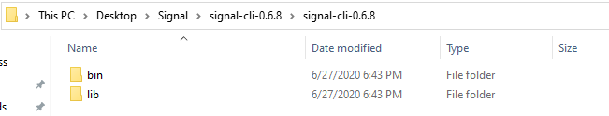

7. Now you will use Git Bash. Click anywhere in the blank area beneath these two folders and choose “Git Bash Here” from your options menu.

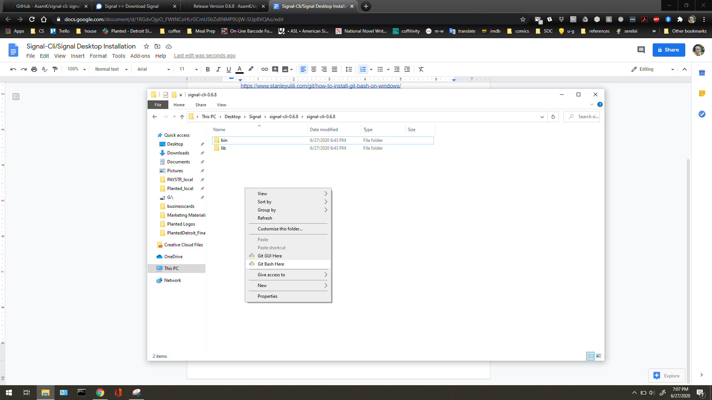

1. In the Git Bash window that opens up, type in “bin/signal-cli -u YOUR_NUMBER register” after the $ sign, and replace the YOUR_NUMBER part with your phone number you used to sign up for Signal. Include + and your country code, like +15551234567 for example. Press enter to see it run.

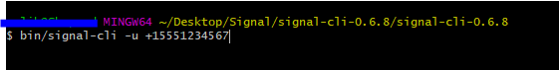

1. You will then get a SMS with a verfication number if it’s a mobile number or else a call. You use this number then to verify your account. Type in “bin/signal-cli -u YOUR_NUMBER verify VERIFICATIONCODE” where, again, YOUR_NUMBER is your number, and VERIFICATIONCODE is your verification code that Signal sent to your phone. Press enter to see it run.
2. Install the latest version of Signal-Desktop from here: <https://signal.org/download/>
3. Open up Signal-Desktop and Signal on your phone. On your phone, you may have to reverify your phone as your Signal device. Do so, and then in the top right corner under Settings, go to Linked Devices.
4. Click the plus icon on the bottom right corner and scan the QR code that pops up on your Desktop version of Signal. Verify your device info is correct and accept.

**Don’t have/can’t get Signal on your phone?**

Follow steps 3-11, and then:

12. Open up Signal on your desktop. Take a screenshot of the QR code that comes up on Signal-Desktop (on Windows, this is SHIFT+PRTSCR)

13. Crop the screenshot to just be the QR code using an image editor of your choice (MS Paint works fine!).

14. Use a QR decoder online like ZXing (<https://zxing.org/w/decode.jspx>) and upload the QR code image. It should spit out a code starting with tsdevice:/? . Copy that code.

15. In Git Bash, type in “bin/signal-cli -u YOUR_NUMBER addDevice --uri “CODE”” and here, replace YOUR_NUMBER with your number, and paste into CODE with "tsdevice:/?uuid..." (in quotation marks), the code that you copied from ZXing (you have to right-click and choose Paste, as Git Bash thinks ctrl+V is what you are typing in).

Open Signal-Desktop and choose a name for your device, then accept.

This should allow you to register your desktop as a device in Signal without a smartphone installation.

*Note: I’m not entirely clear on the below-outlined process as I didn’t get the daemon function to run on my machine, so let me know if it works/doesn’t work.*

1. If you want to automatically **import your contacts** outside of the Signal app on the phone, you’ll need a text editor of choice, signal-cli, and Signal Desktop installed as above. In Windows:

1. Open File Explorer (the folder icon on your taskbar)
2. Navigate to your My Computer/This PC folder
3. Open your main drive (this is usually C:/)
4. Open Users
5. Open your main user folder (whichever user you normally log in as)
6. Open a folder called .local
7. Open the folder called share
8. Open the signal-cli folder
9. Open the data folder
10. In here, there should be a file with the title of your phone number which you used to sign up for Signal (e.g. +15551234567). Open that file with a text editor, like Notepad, Notepad++, or Atom by right-clicking on it and choosing “Open with”.

2. You will see a file that has a bunch of code in it. Scroll down to where you see the word “contactStore”. You will start editing the file here. Select the highlighted area (“contacts” : []) and delete it.

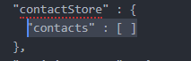

Copy and paste the following template and fill it out in the code, inserting your contacts’ names and numbers in the quotation marks.

"contacts" : [ {

"name" : "name",

"number" : "+1xxxx"

}, {

"name" : "name2",

"number" : "+1yyyyy"

}]

It will end up looking something like this. Then save the file in your text editor and exit.

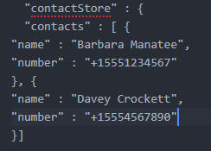

3. Navigate back to your Signal folder and open up Git Bash again if you closed out of it. Now we’re going to activate signal-cli daemon with “bin/signal-cli -u YOUR_NUMBER daemon” and press enter. (Note: I’m not really clear on this step, there might be more involved than I am aware of).

4. While the daemon is running, open Signal-Desktop and go to (File > Preferences > Contacts > Import Now) to import your contacts from the file you just edited. I can’t get this step to function on my machine, so you may have to read up a little more at <https://ctrl.alt.coop/en/post/signal-without-a-smartphone/>.